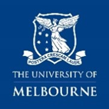
Australian Indigenous Knowledges Collection: 2024 NAIDOC week theme: Keep the Fire Burning! Blak, Loud and Proud
Explore recommended titles aligned to the 2024 NAIDOC Week
Our 2024 NAIDOC week theme Keep the Fire Burning! Blak, Loud and Proud booklist features titles from Giblin Eunson Library Australian Indigenous Knowledges collection. All books in this collection are authored or illustrated by Indigenous Australians or Indigenous Australians have contributed to the development of the title. The collection primarily supports teacher education, however, titles are available for all members of the University community, to borrow and enjoy. This list has been curated by the Education Library team.
Availability notes – shares print copies, ebook copies and availability in Story Box Library.
- Learn more - Use the catalogue links to view if the book is available for borrowing and to access more information. Scroll down the catalogue page, to view integrated resources including, a summary/synopsis of the book, author biographies and access general book reviews.
- Suitability notes
- These support selection for classroom use and provide a useful guide for parents selecting titles for home reading. The label Young adult readers and above, indicates titles that will also interest adults. We have also included a small selection of titles specifically for educators.
- Many of these titles are relevant for any reader and will enhance cultural competency and develop knowledge of Aboriginal and Torres Strait Islander histories, cultures and perspectives.
- Discover more digital picture books - Explore the Library’s subscription to Story Box Library. You can easily filter by theme and select "Aboriginal and Torres Strait Islander Histories and Culture," to access a collection of titles.

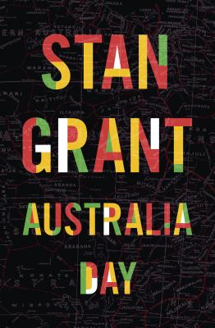 | Australia Day by Stan Grant  Library catalogue link  Suitable for: Senior secondary school, young adult readers and above  Keywords: identity, land, family, race, history, nation, resilience, becoming
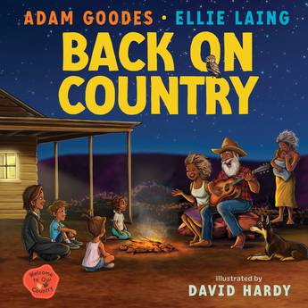 | Back on Country by Adam Goodes, Ellie Laing; illustrated by David Hardy.  Library catalogue link  Suitable for: early childhood, primary school  Keywords: Adnyamathanha culture, connection to Country, kinship, identity
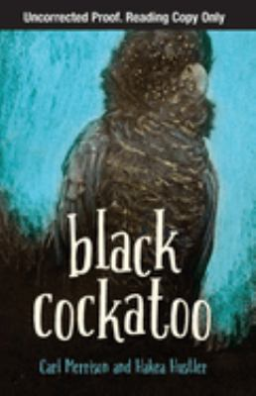 | Black cockatoo by Carl Merrison and Hakea Hustler; illustrations, David "Dub" Leffler.  Library catalogue link | ebook - Library catalogue link  Suitable for: upper primary school, young adult readers and above  Keywords: family, loss, connection to Country, resilience, culture, inner-strength, Jaru Language, bilingual glossary
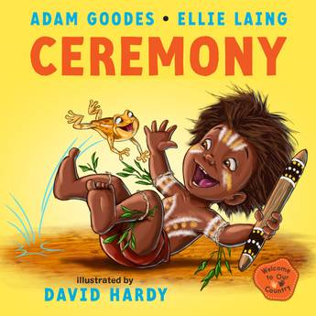 | Ceremony by Adam Goodes and Ellie Laing; illustrated by David Hardy.  Library catalogue link  Suitable for: early childhood, primary school  Keywords: family, connecting to culture, caring for Country, Adnyamathanha language, rhyming
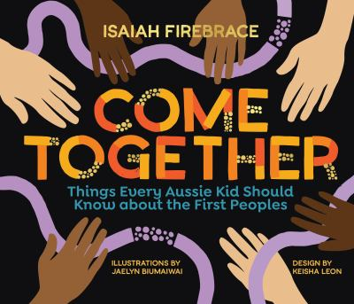 | Come together: things every Aussie kid should know about the First Peoples by Isaiah Firebrace; illustrations by Jaelyn Biumaiwai.  Library catalogue link | Available in Story Box Library  Suitable for: middle to upper primary school, junior secondary school  Keywords: connecting to heritage, Indigenous knowledges, First Nations history, First Nations culture, unity, Yorta Yorta, Gunditjmara

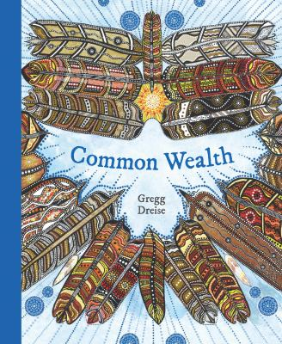 | Common wealth: a slam poetry persuasive by Gregg Dreise.  Library catalogue link  Suitable for: upper primary school, junior secondary school  Keywords: unity, respect, justice, Indigenous Australians, history, national identity, slam poetry, rhyming
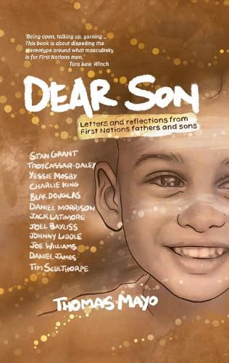 | Dear son: letters and reflections from First Nations fathers and sons by Thomas Mayor; design and illustrations by Tristan Schultz ; artwork by Tony Wilson.  library catalogue link  Suitable for: secondary, young adult readers and above  Keywords: anthology, letters, poetry, fatherhood, masculinity, love, nurturing, racism, inclusion, resilience, culture
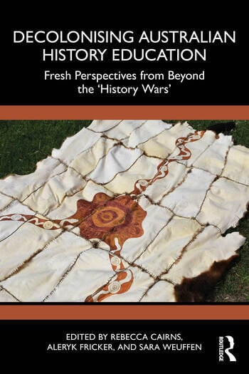 | Decolonising Australian history education: fresh perspectives from beyond the 'history wars', edited by Rebecca Cairns, Aleryk Fricker and Sara Weuffen.  Print - library catalogue link | ebook - Library catalogue link  Suitable for: educators (teacher resource)  Keywords: History education, First Nations history, decolonisation, curriculum
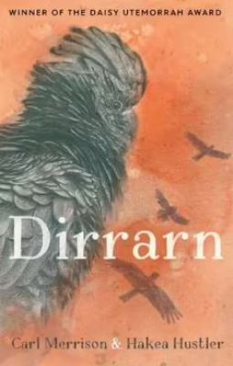 | Dirrarn by Carl Merrison and Hakea Hustler; illustrated by Dub Leffler.  Print - library catalogue link | ebook - Library catalogue link  Suitable for: upper primary school, young adult readers and above  Keywords: school challenges, resilience, growing-up, culture, courage, Jaru language
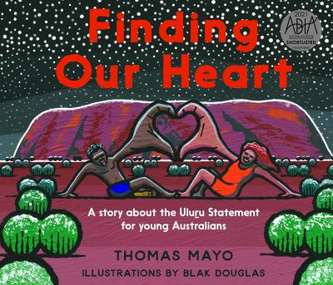 | Finding our heart: a story about the Uluru Statement for young Australian by Thomas Mayor; illustrations by Blak Douglas  Library catalogue link  Suitable for: All levels  Keywords: First Nations, treaty, unity, culture, history, belonging
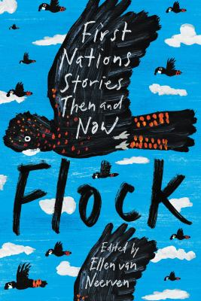 | Flock: First Nations stories then and now edited by Ellen van Neerven.  Print - library catalogue link | ebook - Library catalogue link  Suitable for: young adult readers and above  Keywords: anthology, First Nations storytelling, loss, identity and belonging, connecting to culture, social issues, values
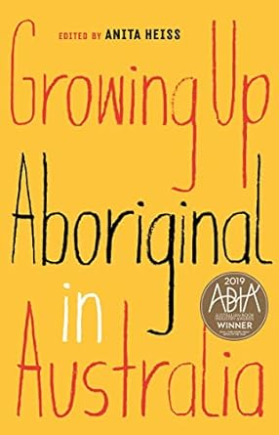 | Growing up Aboriginal in Australia edited by Anita Heiss.  Print library catalogue link | ebook - Library catalogue link  Suitable for: young adult readers and above  Keywords: anthology, First Nations storytelling, resilience, identity, Blak pride, connecting with heritage
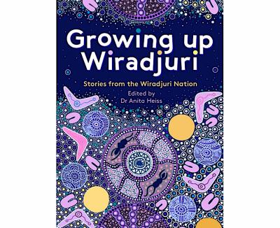 | Growing up Wiradjuri: stories from the Wiradjuri Nation edited by Dr Anita Heiss; illustrated by Charmaine Ledden-Lewis.  Library catalogue link  Suitable for: young adult readers and above  Keywords: personal stories, living culture, connection to Country, coming of age, family, friendship
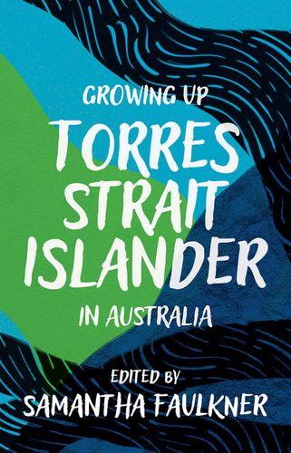 | Growing up Torres Strait Islander in Australia / edited by Samantha Faulkner.  Print library catalogue link | ebook - Library catalogue link  Suitable for: young adult readers and above  Keywords: anthology, First Nations storytelling, resilience, identity, Blak pride, connecting with heritage
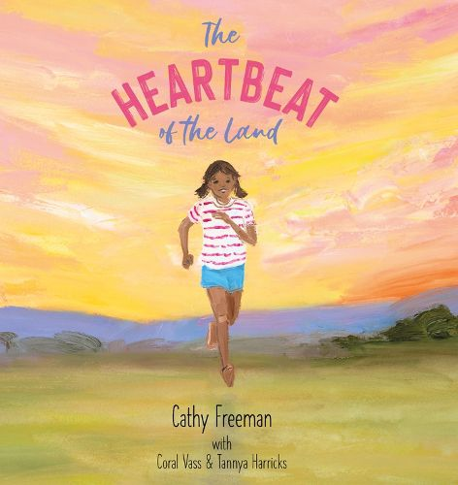 | The heartbeat of the land by Cathy Freeman with Coral Vass & Tannya Harricks.  Library catalogue link  Suitable for: primary school  Keywords: culture, connection with country, spiritual totems, recipes, Kuku Yalanji language
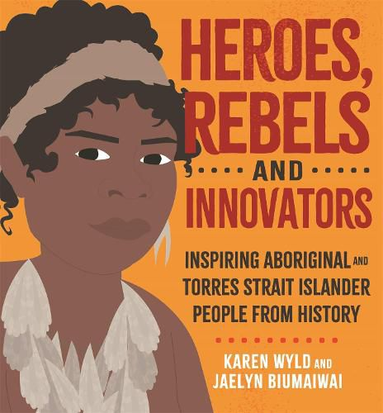 | Heroes, rebels and innovators: inspiring Aboriginal and Torres Strait Islander people from history / Karen Wyld and Jaelyn Biumaiwai.  Print library catalogue link | Available in Story Box Library  Suitable for: primary school  Keywords: Aboriginal and Torres Strait Islander peoples, biographies, history, identity, Blak pride, connecting with heritage
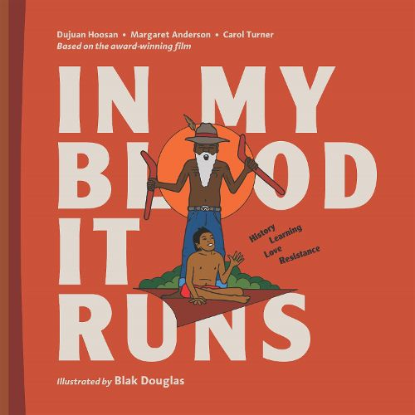 | In my blood it runs by Dujuan Hoosan, Margaret Anderson, Carol Turner; illustrated by Blak Douglas.  Library catalogue link  Suitable for: young adult readers and above  Keywords: First Nations legends, Arrernte people, customs, culture, ancestors, identity, becoming, human rights, justice, criminal responsibility, self-determination
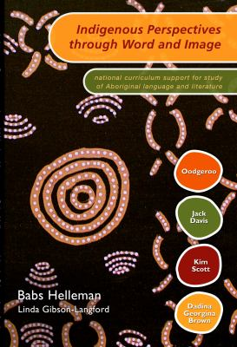 | Indigenous perspectives through word and image: national curriculum support for study of Aboriginal language and literature by Babs Helleman; editor, Linda Gibson-Langford.  Library catalogue link  Suitable for: Educators (teacher resource)  Keywords: Arts, literature, curriculum
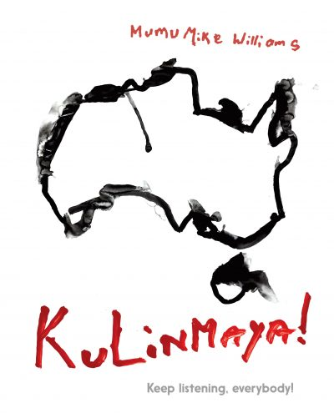 | Kulinmaya! Keep listening, everybody! by Mumu Mike Williams; English translation by Linda Rive.  Print library catalogue link | ebook - Library catalogue link  Suitable for: secondary, young adult readers and above  Keywords: artist, leader, political art, caring for country, land rights, nuclear waste, culture, Anangu people, Tjukurpa law, resilience, Pitjantjatjara language, bilingual
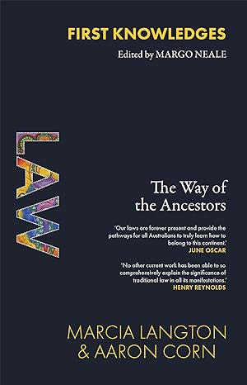 | Law: the way of the ancestors by Marcia Langton and Aaron Corn.  Print library catalogue link | ebook - Library catalogue link  Suitable for: secondary, young adult readers and above  Keywords: Indigenous law, Indigenous rights, civil rights, social change, injustice
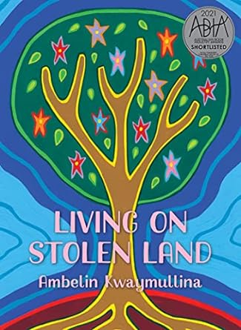 | Living on stolen land by Ambelin Kwaymullina.  Print library catalogue link | ebook - Library catalogue link  Suitable for: Young adult readers and above  Keywords: poetry, decolonisation, Indigenous knowledges, colonialism, First Nations perspectives, bias, racism
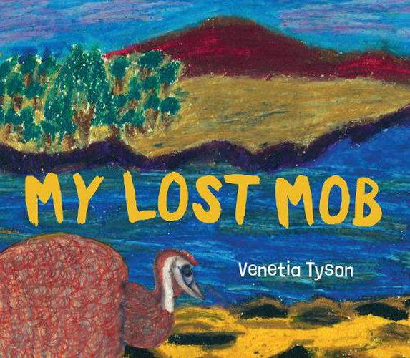 | My lost mob by Venetia Tyson.  Print library catalogue link | ebook - Library catalogue link  Suitable for: early childhood  Keywords: mob, country, emus, kangaroos, belonging, identity, friendship
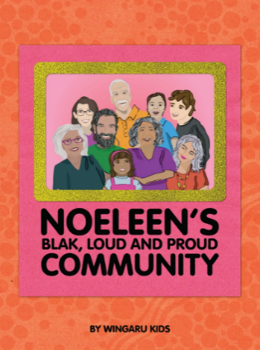 | Noeleen's Blak, Loud & Proud Community by Wingaru kids  Print library catalogue link  Suitable for: Upper primary school  Keywords: Blak pride, culture, resilience
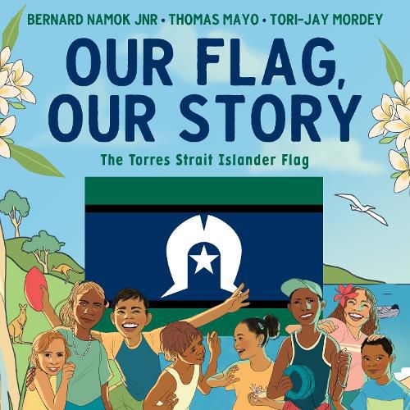 | Our flag, our story: the Torres Strait Islander flag by Bernard Namok Jnr, Thomas Mayo; [illustrations by] Tori-Jay Mordey.  Print library catalogue link | ebook - Library catalogue link  Suitable for: early childhood, primary school  Keywords: Torres Strait Islander flag, symbolism, designs, identity, Blak pride, Torres Strait Islander culture
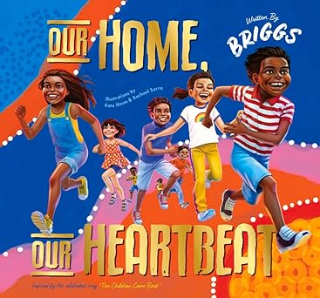 | Our home, our heartbeat by Adam Briggs; illustrated by Kate Moon & Rachael Sarra.  Library catalogue link | Available in Story Box Library  Suitable for: early childhood and above  Keywords: First Nations legends, Indigenous achievements, excellence, Blak pride

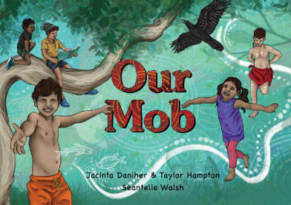 | Our mob by Jacinta Daniher and Taylor Hampton; illustrated by Seantelle Walsh.  Library catalogue link  Suitable for: early childhood, primary school  Keywords: culture, families, First Nations languages, connecting to Country, respect, ceremonies
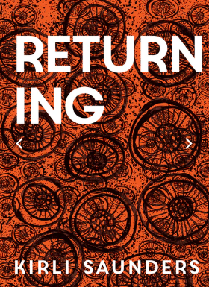 | Returning by Kirli Saunders.  Library catalogue link  Suitable for: upper secondary school, young adult and above  Keywords: connection to Country, poetry, visual art, identity, decolonisation
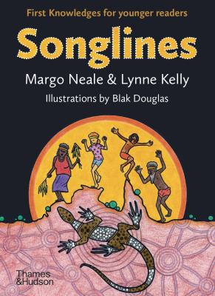 | Songlines: First Knowledges for younger readers by Margo Neale & Lynne Kelly; illustrations by Blak Douglas  Library catalogue link  Suitable for: upper primary school, junior secondary school  Keywords: Deep Time, culture, Indigenous knowledges, connection to Country, sea, and sky
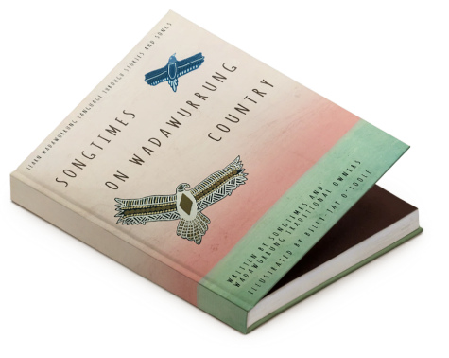 | Songtimes on Wadawurrung country written by Songtimes in collaboration with Wadawurrung Traditional Owners Aboriginal Corporation; illustrated by Billy-Jay O'Toole.  Book and audio CD  Library catalogue link  Suitable for: early childhood, primary school  Keywords: songbook, Wadawurrung language, language revitalization, Wadawurrung country, Wadawurrung identity, connecting to Country, culture
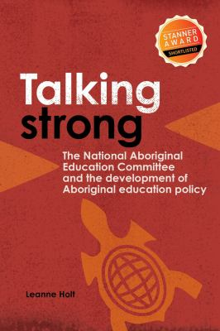 | Talking strong: The National Aboriginal Education Committee and the development of Aboriginal education policy  Library catalogue link  Suitable for: educators, adult readers  Keywords: amplifying First Nations voices, educational policy, history, leadership
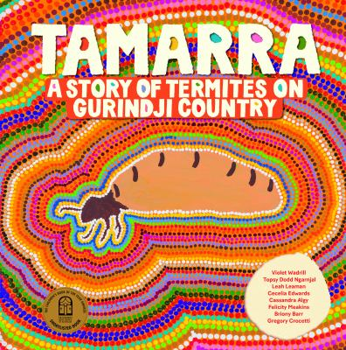 | Tamarra: a story of termites on Gurindji Country  Words by Violet Wadrill, Topsy Dodd Ngarnjal, Leah Leaman, Cecilia Edwards, Cassandra Algy, Felicity Meakins, Briony Barr, Gregory Crocetti ; artwork and photography, Topsy Dodd Ngarnjal, Violet Wadrill, [and twenty-five others].  Library catalogue link  Suitable for: Primary School  Keywords: connecting to Country; Gurindji, Gurindji Kriol and English languages; mothers, babies
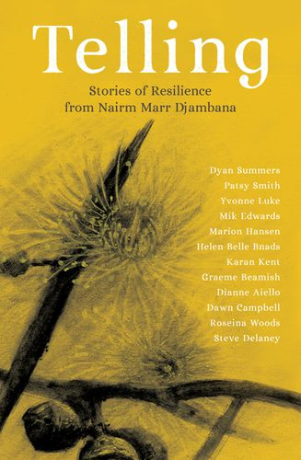 | Telling: stories of resistance from Nairm Marr Djambana edited by Sina Summers; [Nairm Marr Djambana Aboriginal Corporation].  Library catalogue link  Suitable for: Senior secondary school, young adult readers and above  Keywords: anthology, reconnection and resistance, Blak pride, Elders, truth telling, treaties
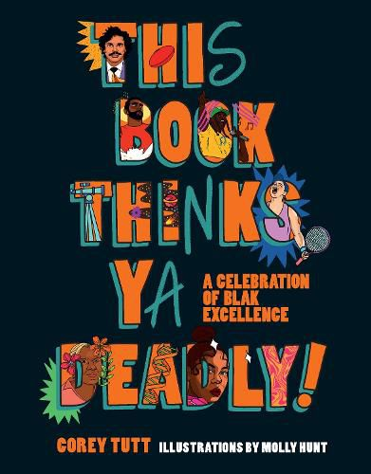 | This Book Thinks Ya Deadly!: A Celebration of Blak Excellence by Corey Tutt ; illustrated by Molly Hunt  Library catalogue link  Suitable for: upper primary school, secondary school  Keywords: Blak excellence, First Nations storytellers, artists, musicians, journalists, educators, scientists, health practitioners and sports legends
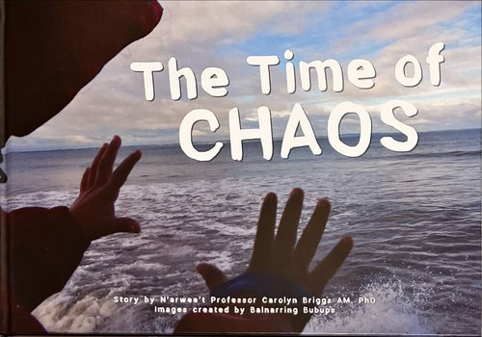 | The time of chaos; story by N'arwee't Professor Carolyn Briggs AM, PhD; images created by Balnarring Bubups.  Library catalogue link  Suitable for: early childhood  Keywords: land, caring for country, climate change, Boon Wurrung language, pictorial dictionary
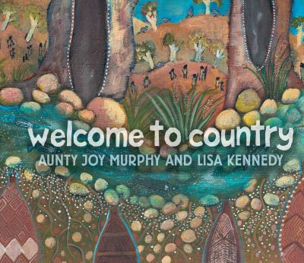 | Welcome to country; welcome words by Aunty Joy Murphy; with illustrations by Lisa Kennedy.  Library catalogue link | Available in Story Box Library  Suitable for: early childhood to primary school  Keywords: Wurundjeri People, Woiwurrung Language, customs, communication, ceremony
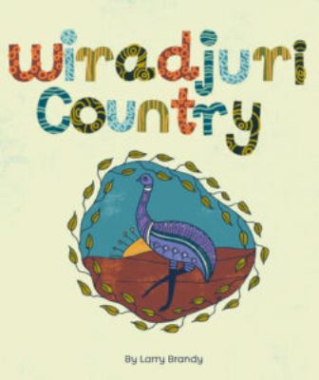 | Wiradjuri Country by Larry Brandy.  Library catalogue link  Suitable for: primary school to junior secondary school  Keywords: connecting to Country, rivers, First Nations storytelling, Wiradjuri Language and culture
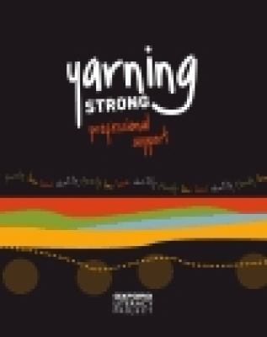 | Yarning strong: professional support.  Library catalogue link  Suitable for: educators (teacher resource)  Keywords: culture, family, law, land, identity
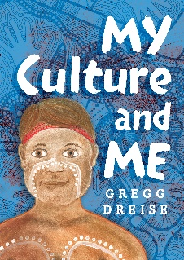 | My Culture and Me by Gregg Dreise  Library catalogue link  Suitable for early childhood, primary school  Keywords: Indigenous identity, Connecting to Country, celebrating culture, dancing and music, Blak pride, belonging, rhyming, Emu totem
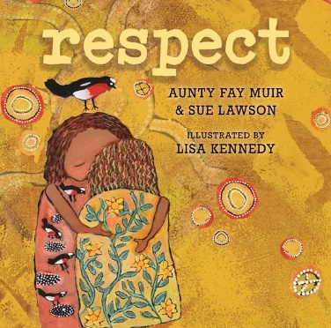 | Respect by Aunty Fay Muir and Sue Lawson; illustrated by Lisa Kennedy.  Library catalogue link  Suitable for: early childhood, primary school  Keywords: Connecting to country, Respecting elders, self-respect, values, Indigenous Knowledges, listening, learning, sharing, family
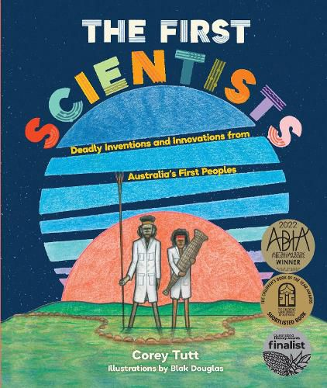 | The First scientists: deadly inventions and innovations from Australia's First Peoples by Corey Tutt; illustrations by Blak Douglas.  Print - Library catalogue link | ebook - Library catalogue link  Suitable for: upper primary school, secondary  Keywords: Indigenous Knowledges, First Nations scientists, Elders, contemporary First Nations scientists, Connecting to Country, astronomy, engineering, chemistry, ecology, land management
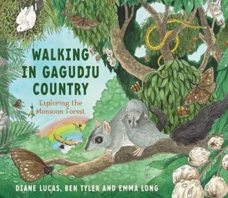 | Walking in Gagudju Country: exploring the monsoon forest by Diane Lucas and Ben Tyler; illustrated by Emma Long.  Library catalogue link  Suitable for: primary school  Keywords: Connecting to Country, monsoon forests, Gagudju, Kundjeyhmi language, Indigenous
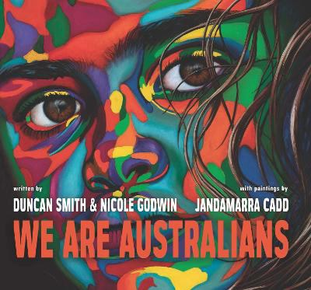 | We are Australians written by Duncan Smith and Nicole Godwin; illustrated by Jandamarra Cadd  Library catalogue link | Available in Story Box Library  Suitable for: All levels  Keywords: First Nations, national identity, citizenship, cultural awareness
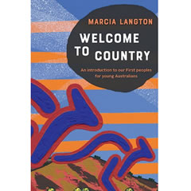 | Welcome to country: an introduction to our first people for young Australians / Marcia Langton.  Print - Library catalogue link | ebook - Library catalogue link  Keywords: Indigenous Australia, Indigenous History, Indigenous Culture, Connecting to country, travel guides and directories, etiquette for visitors, maps  Suitable for: upper primary school, secondary
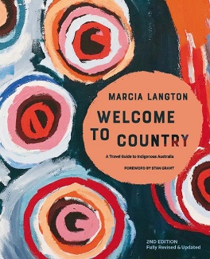 | Welcome to Country: A travel guide to Indigenous Australia (2nd ed.) by Marcia Langton with Nina Fitzgerald, Marly Wells, Tahlia Eastman, Rebekah Hatfield and Dino Hodge; foreword by Stan Grant.  Library catalogue link  Suitable for: secondary, young adult readers and above  Keywords: Indigenous Australia, Indigenous History, Indigenous Culture, Connecting to country, travel guides and directories, etiquette for visitors, maps

